TEAM4OIES

Input Forms and Output Reports

Version 1.0

Signature Block

COSC 4351 | Name Signature | Date
SE Team Leader | Javier Rivera
SE SQA | Linh Tong
SE SQA | Paul Miller
SE Team Leader
SE SQA
SE SQA
SE Team Leader
SE SQA
SE SQA
Example Actor: Guest
1. Search Testimonials: A guest is able to search through testimonials at their leisure. Once entering the site they will be presented with a button they must press to see available testimonials. After pressing the button the guest will see a table full of testimonials sorted by date.

Input Form:

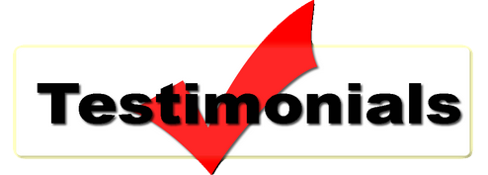

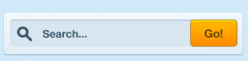

Output Report:
Testimonial | Date
I love this site!! | 03-March-2013
I love to shop here. | 07-April-2014

Document Control
Change History
Table 1: TLs entries (assigned work and due dates) before releasing to the team (all SQAs)
Revision | Name | Due Date | Description
1.A | TM Daniel Gonzalez | 02/08/2015 | Add your work to Document
1.B | TM Steven Pate | 02/08/2015 | Add your work to Document
1.C | Jainesh Mehta | 02//08/2015 | Add your work to Document
1.X | Paul Miller | 02/09/2015 | Review Document
1.Y | Linh Tong | 02/09/2015 | Review Document

Table 2: Entries when work completed (SVN Commit Comment matches Description)
Revision | Name | Completed Date | Description
1.A | TM & Name | XX/XX/XXXX | I …..
1.B | TM & Name | XX/XX/XXXX | I …..
1.C | DBA & Name | XX/XX/XXXX | I …..
1.X | SQA & Name | XX/XX/XXXX | I reviewed Document
1.Y | SQA & Name | XX/XX/XXXX | I reviewed Document

(PLEASE REMOVE THIS BEFORE COMMITTING TO SVN!
NOTE: At the time of RED TEAMS DELIVERABLES, the Team Leaders should change the version on the COVER PAGE to 2.0 BEFORE COMMITTING back to SVN!!! Thus the last entry in CHANGE HISTORY should be the TLs)

Table 3: TL entry for RED DELIVERABLES (SVN Commit Comment matches Description)
Revision | Name | Due Date | Description
2.0 | TL Javier Rivera | 02/11/2015 | I changed Version to 2.0

Document Storage
This file is stored in SVN at https://svn.cs.uh.edu/svn/cosc4351/team4/TEAM PROJECT DELIVERABLES/Input Forms and Output Reports.doc.

